GROUP H- Restaurant Management System

Students: Lallbejadhur, Appavoo, Lalbahadoor

server-side wed programming

LECTURE 3- HOMEWORK

1. **Define All the aspects of your application**

|  |  |
| --- | --- |
| **1. User Management** | |
| **Feature** | **Details** |
| **Roles** | Admin (full system access), Manager (inventory/orders), Staff (take orders), Customer (place orders) |
| **Authentication** | Email/username login, password reset, session timeout (30 mins inactivity) |
| **Profile Control** | Edit personal info, profile photos, notification preferences (SMS/email) |
| **Permissions** | Admin: Add/delete users; Manager: Update menu; Staff: Process orders |
|  |  |
| **2. Menu Management** | |
| **Feature** | **Details** |
| **Categories** | Main Course, Appetizers, Deserts, Drinks |
| **Menu Items** | Name, description, price, prep time, calorie count, allergens (nuts/dairy), drink(cold/hot) |
| **Dynamic Pricing** | Happy hour discounts, seasonal specials, combo deals, Kids meal |
| **Availability** | Real-time stock sync (disables item if ingredients run out) |
|  |  |
| **3. Order Management** | |
| **Feature** | **Details** |
| **Order Types** | Dine-in (table assignment), Takeaway (pickup time selection), Delivery (live GPS tracking) |
| **Workflow** | Status: Received → Preparing → Ready → Completed/Cancelled |
| **Modifications** | Custom requests (e.g., "no ketchup"), ingredient substitutions |
| **Payment** | Split bills, tips (10%/15%/20%), digital receipts |
|  |  |
| **4. Inventory Management** | |
| **Feature** | **Details** |
| **Stock Tracking** | Quantity, unit (kg/liters/pieces), expiry dates, minimum threshold alerts |
| **Suppliers** | Contact info, order history, delivery schedules |
| **Waste Control** | Track spoiled items, generate waste reports |
| **Auto-Reorder** | Trigger purchase orders when stock ≤ minimum threshold |
|  |  |
| **5. Reporting & Analytics** | |
| **Feature** | **Details** |
| **Sales Reports** | Daily/weekly/monthly sales, top-selling items, peak hours |
| **Staff Performance** | Orders handled per employee, average preparation time |
| **Customer Insights** | Favorite items, average spend, visit frequency |
|  |  |
| **6. Customer Relationship** | |
| **Feature** | **Details** |
| **Reservations** | Table booking via app/website, waitlist management |
| **Loyalty Program** | Points system (1 point per $10 spent), redeemable discounts |
| **Feedback** | Rating (1-5 stars), comments, complaint resolution tracking |
|  |  |
| **7. Billing Management** | |
| **Feature** | **Details** |
| **Payment Methods** | Accepts cash, credit/debit cards (Visa, Mastercard, etc.), mobile wallets and bank transfers. |
| **Grand total** | Sum of all ordered items. |
| **Taxes** | Auto-applied based on location (e.g., GST, VAT). |

2. DTOs:

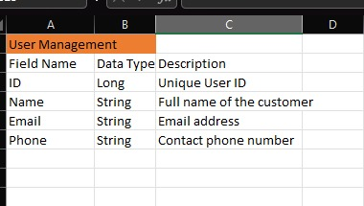

Stores data about the employees of the restaurant e.g name and NIC of employee

Stores data about the menu of the restaurant e.g what the restaurant is producing on a specific day

Stores data about the orders of the restaurant e.g the number of orders on a specific item(popularity)

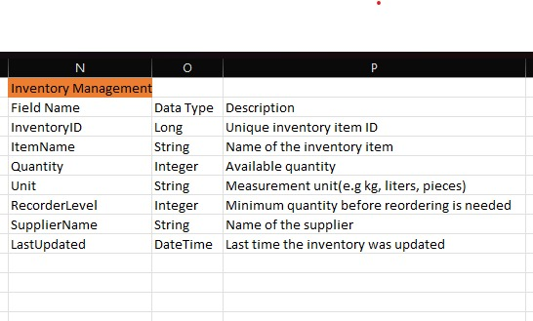

Stores data about the inventory of the restaurant e.g the amount of bread in store

Stores data about the transactions of the restaurant e.g electricity bills

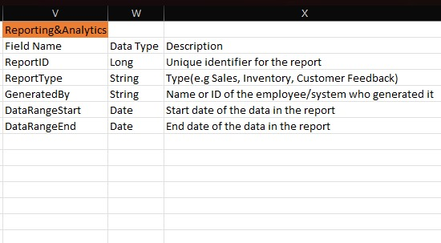

Stores records of the growth of the restaurant e.g profits, popularity

Stores data about the customers of the restaurant e.g the loyal customers and new ones which can be used to add to an analysis

3. Pages

Login Page :

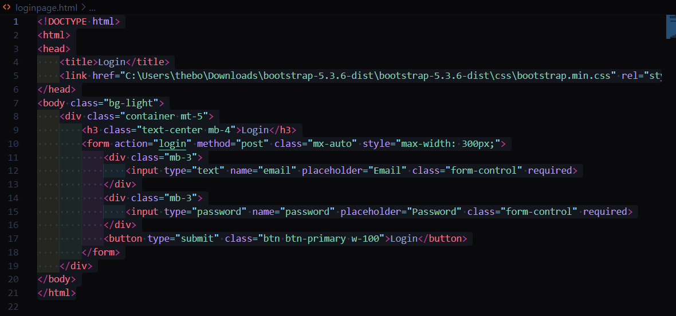

Table page :

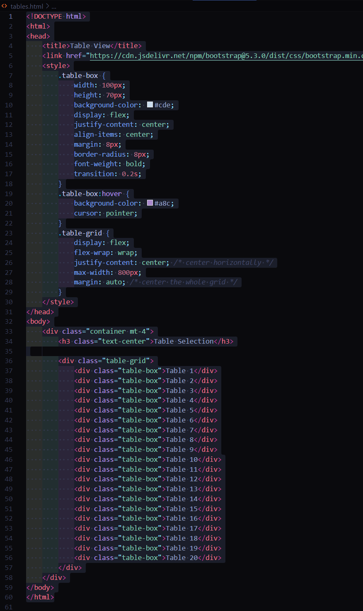

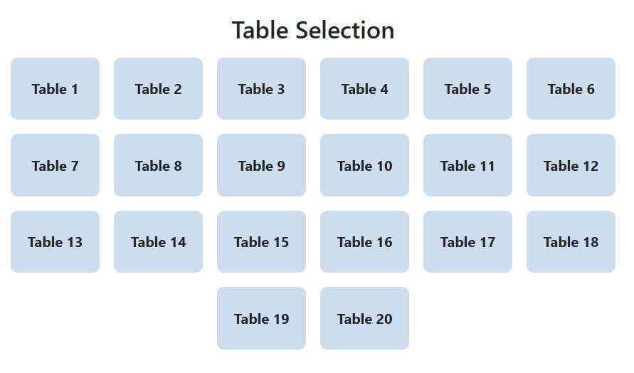

Menu :

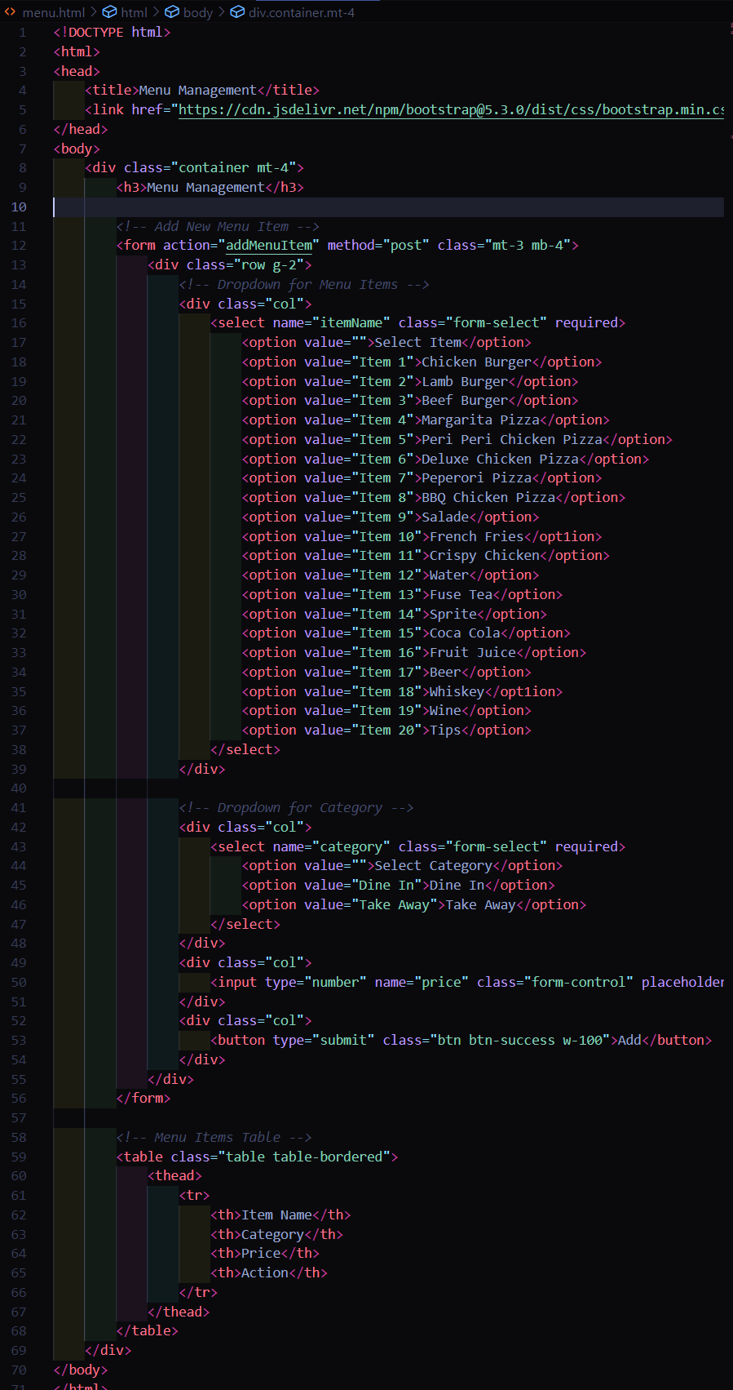

Billing :

4. github address for the project

<https://github.com/Ar1ley/restaurent-management-system.git>